- UK inflation surprised on the downside in February, but this was largely due to an unusually weak reading in the clothing category, which should unwind in March. The outlook remains largely unchanged, though the recent decline in wholesale gas prices has led us to nudge down our 2025 CPI forecast to 3.1%, from 3.2% before.
- We expect inflation to pick up sharply from April, as large regulated price increases come into play and firms reflect rising labour costs in their prices. Inflation is forecast to peak in the autumn then start to cool, as the contribution from the energy category fades.
CPI inflation slowed to 2.8% in February from 3% in January, an outturn that was fractionally lower than our forecast and consensus expectations. February's fall was primarily driven by an unusually soft outturn in the volatile clothing category, with the Office for National Statistics suggesting that this was linked to signs of greater discounting in February. This could be due to the choice of a later-than-usual collection date. Elsewhere, the main CPI categories remained relatively steady. RPI and RPIX also fell by 0.2ppts in February to 3.4% and 3% respectively.
Looking ahead, several factors should push headline inflation higher in the near-term. Large regulated price increases will take effect from April, with a 6.4% rise in the energy price cap and a substantial jump in water bills. Firms are also likely to pass on some of the rise in labour costs caused by increases in employers' national insurance contributions and the National Living Wage, which is likely to slow the decline in services inflation. We expect CPI inflation to temporarily hit 3.6% later in the autumn before falling back.
Our inflation forecast is little changed compared with last month. February's drop in clothing prices should unwind in March. Meanwhile, the fall in wholesale gas futures prices in late-February means we now expect a slightly softer increase in the contribution from the energy category during the summer. As a result, we now expect CPI inflation to average 3.1% in 2025, 0.1ppt lower than last month's forecast.
Chart 1: CPI inflation is forecast to average 3.1% in 2025
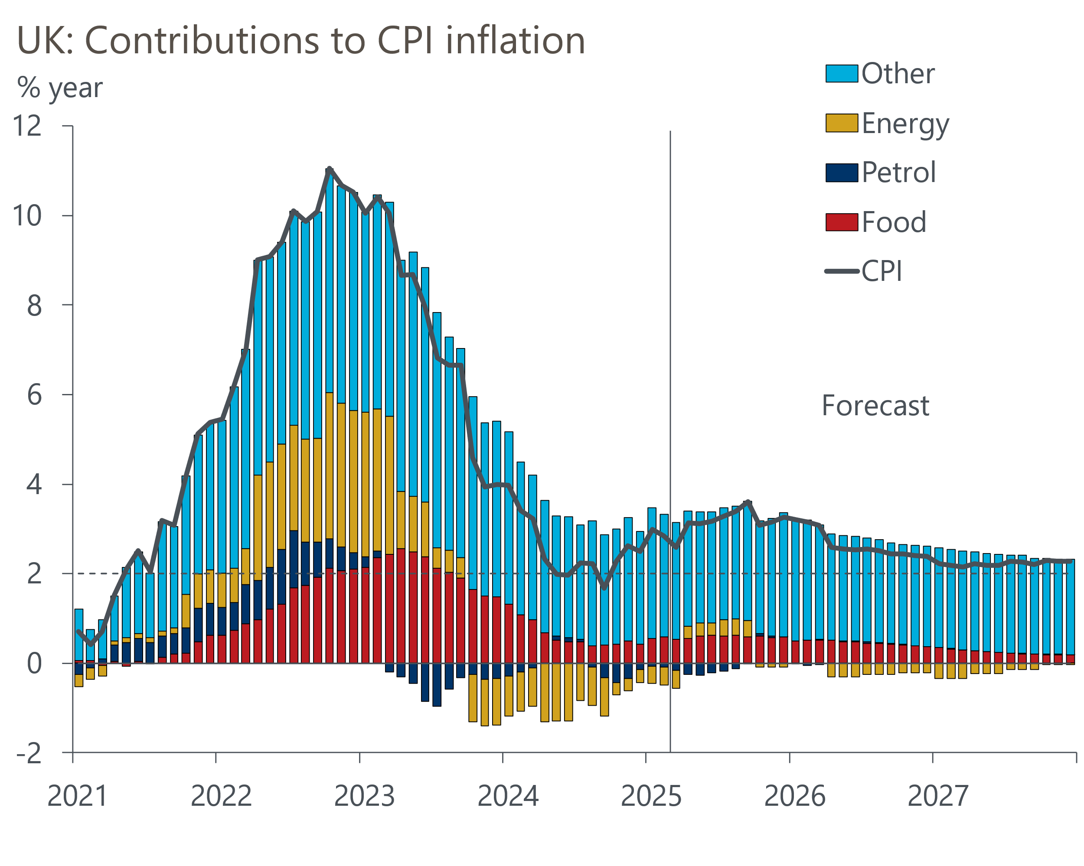
Source: Oxford Economics, Haver Analytics

